جامعة المنارة

كلية: الصيدلة

اسم المقرر: الكيمياء الحيوية السريرية

رقم الجلسة (7)

عنوان الجلسة

حالات سريرية

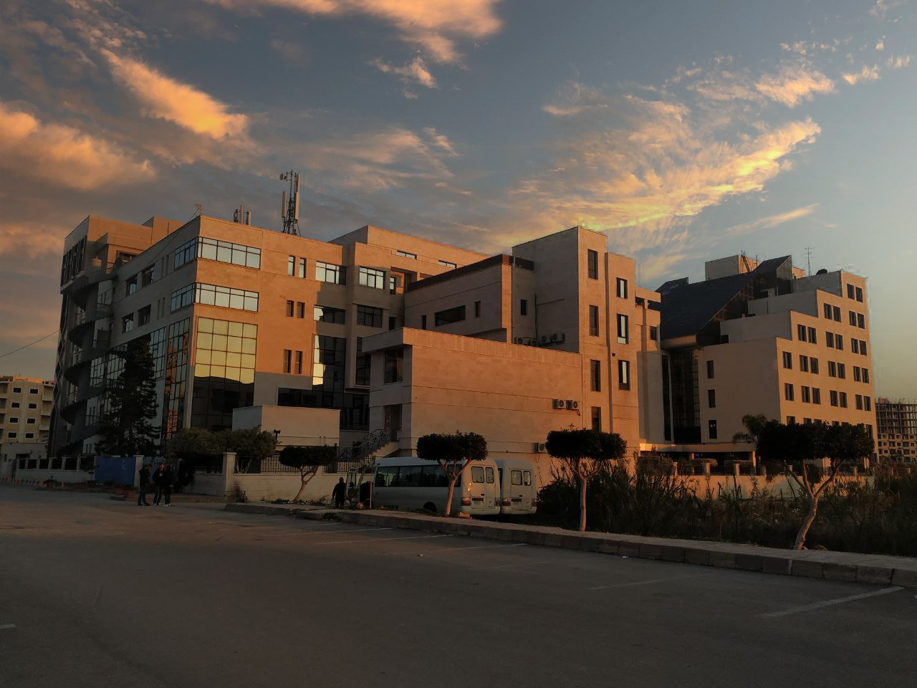
الفصل الدراسي الثاني العام الدراسي2022-2023

جدول المحتويات
Contents
العنوان | رقم الصفحة
الغاية من الجلسة | 3
الحالة الأولى | 3
الحالة الثانية | 6
الحالة الثالثة | 9

الغاية من الجلسة:
مناقشة بعض الحالات السريرية والتدريب على قراءة النتائج وتفسيرها.
الحالة الأولى:
A 20-year-old female college student with a sore throat is seen in the student health service. A throat swab is cultured and reported positive for group A β-hemolytic streptococci. She is treated with intramuscular injection of penicillin. Two weeks later, she wakes up in the morning and finds she has decreased urine volume and her urine is dark red. She also has a fever and swelling in her feet. She returns to the student health service, where urine is collected for urinalysis. The following urinalysis results were obtained:
Physical appearance:
Color: | red
Transparency: | cloudy

Chemical screening:
pH | 6
specific gravity | 1.025
protein (reagent strip) | 100 mg/dL
protein (SSA) | 2 +
blood | large
nitrite | negative
leukocyte esterase | negative
glucose | negative
ketones | trace
bilirubin | negative
Urobilinogen | normal

Microscopic examination:
RBC | 10-15 per hpf, dysmorphic forms present
WBC | 0-2 per hpf
Casts | 2-5 red blood cell casts per hpf
Crystals | moderate amorphous urates

- List of abnormal findings
- In this case, the proteinuria is probably due to which of the following?
  - Glomerular damage
  - Lower urinary tract disorders
  - Pre-renal disorders
  - Tubular damage
- The presence of dysmorphic red cells and red cell casts indicates which of the following?
- Bleeding due to kidney stone formation
- Kidney disease located in the glomerulus
- Kidney infection
- Probable menstrual contamination
- The trace reagent strip reaction for ketone and the presence of amorphous urates in the urine sediment of this patient are probably the result of:
- A false-positive ketone reaction due to sensitivity of the test
- Dehydration due to fever with concentration of urine
- The presence of dysmorphic red cells and red cells casts
- The presence of protein

- Which of the following conditions is exhibited by this patient?
- Acute cystitis
- Acute drug-induced interstitial nephritis
- Acute glomerulonephritis
- Acute pyelonephritis
- Nephrotic syndrome

الحالة الثانية:
An 8-year-old- girl complains of feeling like she needs to urinate all the time. Her urine burns when she does void and it is cloudy. She is seen by her pediatrician, where urine is collected for routine urinalysis and culture. The following urinalysis results were obtained:
Physical appearance:
Color: | pale
Transparency: | cloudy

Chemical screening:
pH | 7.5
specific gravity | 1.010
protein (reagent strip) | trace
protein (SSA) | trace
blood | negative
nitrite | positive
leukocyte esterase | positive
glucose | negative
ketones | negative
bilirubin | negative
Urobilinogen | normal

Microscopic examination:
RBC | 0-2 per hpf
WBC | 50-100 per hpf, clumps of white cells seen
Casts | None seen
Crystals | moderate amorphous phosphate
Bacteria | many rods

- List of abnormal findings
- The positive reagent strip test for nitrite in the patient is probably due to which of the following?
- An infection due to gram-negative bacteria
- An infection due to gram-positive bacteria
- An infection due to yeast
- An old urine specimen, unsuitable for examination
- The positive reagent strip test for leukocyte esterase in this case is due to the presence of which of the following?
- Amorphous phosphates
- Bacteria
- Nitrite
- Protein
- Red blood cells
- White blood cells
- This patient’s alkaline pH is cause by the presence of which of the following?
- Bacteria
- Leukocyte esterase
- Nitrite
- Protein
- White blood cells
- This patient’s proteinuria is probably caused by which of the following:
- Glomerular damage
- Lower urinary tract infection
- Pre-renal disorders
- Upper urinary tract infection
- Which of the following conditions is exhibited by this patient?
- Acute cystitis
- Acute drug-induced interstitial nephritis
- Acute glomerulonephritis
- Acute pyelonephritis
- Nephrotic syndrome

الحالة الثالثة:
A 12-year-old boy has a history of several infections in the past few months. He is now very lethargic and swollen, with generalized edema. He tells his mother that his urine is very foamy when he urinates and that he feels “awful”. He is seen by his pediatrician, and urinalysis is performed with the following results:
Physical appearance:
Color: | pale
Transparency: | cloudy
Foam | abundant, white foam

Chemical screening:
pH | 6
specific gravity | 1.010
protein (reagent strip) | > 2000 mg/dL
protein (SSA) | 4 +
blood | trace
nitrite | negative
leukocyte esterase | negative
glucose | negative
ketones | negative
bilirubin | negative
Urobilinogen | negative

Microscopic examination:
RBC | 0-2 per hpf
WBC | 0-2 per hpf, clumps of white cells seen
Casts | 5-10 fatty casts per hpf, 2-5 hyaline casts per hpf
Epithelial cells | Few renal epithelial cells, many oval fat bodies present
Other | Moderate free fat globules seen

- List of abnormal findings
- The abundant white foam in the urine specimen is due to the presence of which of the following?
- Blood
- Casts
- Fat
- Protein
- The edema seen in this patient is due to the presence of which of the following?
- Blood
- Casts
- Fat
- Protein
- oval fat bodies, renal epithelial cells, and free fat in this case indicates which of the following?
- A lower urinary tract infection UTI
- An allergic reaction
- An upper urinary tract infection UTI
- Severe renal dysfunction, probably glomerular
- Which of the following conditions is exhibited by this patient?
- Acute cystitis
- Acute drug-induced interstitial nephritis
- Acute glomerulonephritis
- Acute pyelonephritis
- Nephrotic syndrome

